**Functionality guide**

## Group 5: Yanzhang Wu, Thanwa Chaichankanchang, Boling Zhang, Xingyun Zeng

# Description:

It’s a warehouse management system for clothing store employees to use. The system is designed for two roles, user and administrator. Users can register and log into the system, as well as check or edit the records of items. Administrators can use this system to management user accounts and admin accounts.

# Highlights:

1. Frontend and backend separation.
2. Animated Login page and signup page.
3. Redirecting anonymous users to index page if they try to access management pages.
4. CRUD are implemented within one html page.
5. Frontend validation and backend validation.

# Two Roles of User with Different Permission

We create two roles of users - administrator and regular user, to perform functions with different permissions to the different databases. Users can choose their roles on the index page.

Figure 1. Index Page

## User Login Portal

1. The login page has the frontend validation. If user inputs don’t meet the requirements, the login request will not be processed.

Figure 2. Frontend Validation—User Login Page

1. When the users’ inputs pass the frontend validation, the backend will check if the username and password match the records in the database. If the validation fails, the error message will be displayed.

Figure 3. Backend Validation—User Login Page

1. Users could register through the Signup page in which frontend validation applies as well.

Figure 4. Frontend Validation - User Signup Page

1. Signup page also includes backend validation. If there are duplicated usernames to be registered, the error message will be displayed..

Figure 5. Backend Validation - User Signup Page

1. If the login is successful, user will be directed to the itemManagement.html. Animation will be played during the page loading.

Screenshot : Loading Animation Before Displaying Page to User

1. Anonymous guests do not have permission to access itemManagement.html. They will be redirected to the index page.

Screenshot : Error Message of Anonymous Access

Screenshot : Redirect to the Index Page

## Admin Role

The administrator role can access the tables of administrator management and user manaement. Administrator can do CRUD manipulations of the records in these tables. After the successful login, it will display the admin management table to the user by default. User can click the tags on the side bar to switch between different tables.

Screenshot : Display Admin Management by Default

Screenshot : Switch to User Management Table

## Regular User Role

The regular user role can access the item management table. User can do CRUD manipulation on this table. After the successful login, it will display the item table to the user.

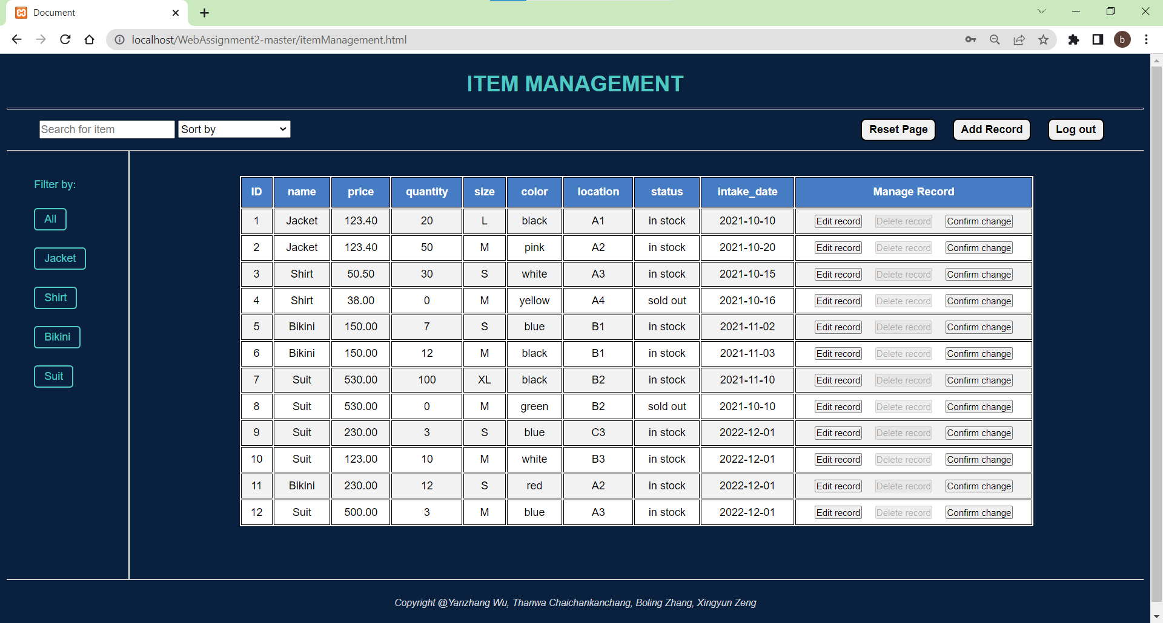

Screenshot : Display Item Management Table

# CRUD Manipulation of Data (use regular user role as an example)

## Add Record

1. User can add records by clicking the “Add Record” button. It will display one line of input boxes for user to insert data. The new record will be appended to the end of table.

Screenshot : Input Boxes for Inserting Records

1. The input data will need to pass the backend validation before being inserted. If user inserts any invalid data into the boxes, it will display the error message on the screen and fail to create the data. For example, if user tries to insert a string to the “Price” column, it will fail the validation.

Screenshot : Error Message of Backend Validation on the Input Value

1. If it can pass the validation, user should click the “Confirm Change” button to ensure the creation of the record.

Screenshot : Confirm the Creation of Record

1. If user leave the ID number empty, it will automatically increment the ID number based on the records.

Screenshot : Leave the ID Number Input Box Empty While Inserting Record

Screenshot : Auto-Increment of ID Number Value

## Edit Record

1. User can edit the records by clicking the “Edit Record” button beside the records. User should click “Confirm Change” button after updating the records.

Screenshot : Confirm the Change of Values

1. Same as the case when user tries to add invalid records to the table, if user changes the values of records into invalid data, it will display error message and reject the update.

Screenshot : Error Message of Backend Validation on the Updated Values

## Delete Record

To ensure the safety of the data, user should click “Edit Record” first before deleting the records. The “Delete Record” button is disabled before user click “Edit Record” button.

Screenshot : “Delete Record” Button is Disabled Before Clicking the “Edit Change” button

Screenshot : “Delete Record” Button is Enabled After Clicking the “Edit Change” button

## Display Tables in Customized Manners

### Searching function

User can search the items based on the name by using keywords in the search bar. Note that the matching of keywords is not case-sensitive.

Screenshot : Using Keywords to Search for Records

### Sort by function

User can use “Sort by” option drop-down list to display the records in different orders. Based on the columns, it can display data either in ascending way or descending way.

Screenshot : “Sort by” Drop-down List Options

Screenshot : Sort Records by “ID Descending” Order

Screenshot : Sort Records by “Lowest Price” Order

Screenshot : Sort Records by “Highest Price” Order

Screenshot 25: Sort Records by “Oldest Intake Date” Order

Screenshot 26: Sort Records by “Newest Intake Date” Order

### Filtering function

User can filter the records of items based on their categories. The category tags are listed on the side bar. By clicking the different tags, user can filter the records.

Screenshot 27: Filter Records Using Buttons on the Side Bar

### Reset Table

After displaying the table in different ways, user can click the “Reset Page” button to reset the table back to the default arrangement.

Screenshot 28: Reset the Table to the Default Arrangement

## Log out

By clicking the “Log Out” button, it will direct to the index page immediately.

Screenshot 28: Redirect to the Index Page after Logout